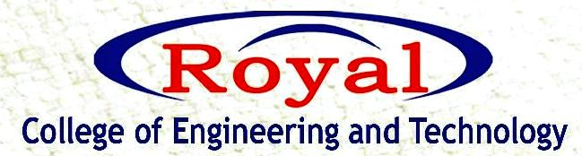
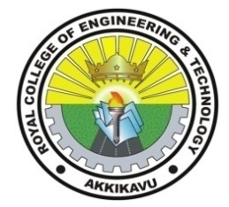
IEDC
“MEET THE FOUNDER”
WEBINAR

RCET IEDC organized an online webinar on the topic “How to build a startup” for the students on October 16th, 2021 through Google meet. The keynote speaker was Mr. Akhil Madhav, Maker manager at Nasscom Foundation, Bangalore. Approximately 119 students took part in the session. Registration link was provided to the students to register for the event.
The session started by 11.10 am with a silent prayer .The welcome speech was given by Mrs. Neethu Assistant professor, Computer science department .She gave us a brief idea about IEDC.The session by Mr. Akhil Madhav was quite active and interesting. Students were requested to respond through the chat box.The session was very interactive and there was good cooperation and response from the students. He discussed how to find real life problems and to find solution to the problems through brain storming.
Our respected principal Dr.Devi V M thanked the guest as well as the whole IEDC team for arranging this session. The program concluded with a vote of thanks. Feedback link was provided in the chat box and based on that E-certificates are provided to all the students who attended the session.
